**Bank Note Authentication using Machine Learning Techniques**

Ilfa Shaheed Valiyavallappil

Department of Computer Science,

Birla Institute of Technology and Science, Pilani,

Dubai International Academic City,

Dubai, United Arab Emirates

**ABSTRACT**

Every country incorporates a set of security features on a banknote for economic protection. However, counterfeiters find multiple ways to forge banknotes and replace genuine banknotes. A counterfeit currency can be defined as an illegal imitation of the national or state currency created to seem as if it is approved by the government. Counterfeit banknotes have always imposed an obstacle in the monetary system worldwide. With the advancements in printing technology, criminals have found loopholes to manipulate genuine banknotes and generate fraudulent banknotes. Through the circulation of counterfeit banknotes, there is a high potential risk for inflation that may reduce the value of the currency and create an economic crisis around financial transactions in various GDP-contributing industries. It has a major risk to dismantle the economic as well as the financial growth of a country. Businesses face financial losses on acceptance of counterfeit banknotes since they encounter trouble when exchanging or depositing corrupt money in a bank. Even after the introduction of demonetization counterfeiters have adapted to the new currency version immediately, attempting to produce new notes in a short period. There is an emerging need for an automated system to identify counterfeit banknotes to be installed at banks. Machine learning (ML), a subset of artificial intelligence, is the ultimate solution to the ominous issue of counterfeiters. This paper utilizes various supervised learning algorithms of machine learning like Logistic Regression, random forest classifier, decision tree, AdaBoost, and support vector machine (SVM) to finalize the most accurate model to distinguish between a forged banknote and a genuine banknote. SVMs enable excellent distinctions between classes in highly dimensional feature spaces, whereas ensemble techniques including random forests and gradient boosting enhance the long-term reliability and accuracy of banknote systems for authentication. The models are trained on a large dataset that identifies specific features that act as key discriminators between a counterfeit banknote and an original banknote. Banknote metadata is extracted from various images via an instrument referred to as the wavelet transform tool. It allows the ML model to learn all possible complex patterns contributing to the authentication of a particular banknote. Metrics are employed to measure the accuracies of the several models created and rank them in order of highest to lowest accuracies. This paper uses Metrics as a determining factor in the decision of the most accurate model that has a better chance of authenticating a genuine banknote and alerting the respective authorities if it is forged.

**INTRODUCTION**

What is the purpose of economic and financial growth of a government of the state or nation when the transactions of money are counterfeited? Counterfeiting is the process of altering or forging a banknote that closely mimics an original banknote issued by the state or country's central bank. The main goal of counterfeiting is to defraud businesses and financial institutions for personal gain. According to the statistics an estimate of $1.7 trillion to $4.5 trillion goes around in the selling of counterfeit goods every year. The immense amount of investment in counterfeiting can be equated to an economy larger than that of Canada’s total GDP. The rapid circulation of forged banknotes has made it quite impossible to track down the source of counterfeiting, making it easy for criminals to evade official authorities and complete fraud transactions. The counterfeit banknotes are developed and produced in all denominations that decelerate the financial market and give rise to the black market. Counterfeit banknotes are built in with the similar security features as the genuine banknotes making it very difficult to differentiate them. It is a major hurdle to distinguish between forged and genuine banknotes due to their similar imitations to the real ones. It is a highly tedious process to manually inspect each banknote, especially when brought in bulk. This demands the need for a security measure to be initiated in all banks overseeing any exchange or deposit of counterfeit money. With developments in artificial intelligence, machine learning paves a way in finding out the apt solution.

In recent times, machine learning has solved numerous conventional challenges faced worldwide by using statistical and mathematical techniques. The authentication of banknotes can be categorized into a classification ML query. In issues related to classification, supervised learning algorithms are frequently utilized. A supervised learning model trains on a huge dataset, in this case it trains on certain traits of banknotes that can be used to identify a genuine banknote. It eliminates the need for manual image processing procedures and enables computing technology to detect counterfeit banknotes through the design of algorithms. The algorithms are trained to learn on the complex patterns of each banknote such as watermarks, microprinting and security thread features for an accurate distinction. Users can grasp simple two-class label outputs with the required inputs from the dataset thanks to the model's building design. Machine learning offers a unique capability that makes it possible for you to customize or fine-tune the model for specific banknote authentication tasks. Supervised learning enables the development of robust models against a wide range of banknotes with varying complicated patterns.

Using an industry quality print camera, this paper uses a dataset from the UCI machine learning repository that comprises both faked and real banknote like specimens. In this paper, four models are created on supervised learning algorithms namely, random forest classifier, decision tree, K-nearest neighbors, and support vector machine (SVM). The accuracies are compared, and the best accurate model is chosen. The model can be integrated in banks and in devices that will be useful for individuals and businesses to carry out genuine transactions.

**LITERATURE SURVEY**

Many studies have been undertaken to date on how to overcome the issue of counterfeit banknotes using various machine learning approaches. The following are summaries of the various algorithms employed.

In conference paper [1], they discuss in briefly various currency detection techniques that can be used using different machine learning techniques. It explains that machine learning is divided into two types: Supervised and Unsupervised learning and explains each of the them. Image processing was another technique suggested by the paper to extract features of the images of banknotes. It deals prominently with edge detection and feature extraction. Image processing and pattern recognition are the bases for currency authentication. As there has been developments in the field of artificial intelligence, machine learning techniques are used for banknote authentication now. Classification models such as Logistic Regression and Linear Discriminant Analysis models were developed and compared. It was realized in the end that Logistic Regression Model performed better than LDA with a higher average accuracy. A final predicament was made that statistical models have a higher potential on accuracy and performance.

Analysis of the study [2], explains the importance of the security features differing in each currency of different nations. It discusses why there is a need for automated system software to distinguish between counterfeited and genuine notes since the traditional methods are time consuming and complex. Effective techniques have been developed using infrared spectroscopy and extracting features on exposal to UV radiation methodology involved using real-time images of banknotes and extracting security features from them through pre-processing. Since security features are a prominent feature in certain images, they were classified using a clustering algorithm, k-means algorithm. The latent image on matching with their templates and encoded using HOG descriptor is classified using SVM classifier.

In the journal [3], it discusses physical currency as the most important asset of a nation. Humans alone cannot differentiate between a genuine and a forged banknote which calls for the help of machine learning techniques. The study shows the creation of SVM and calculation of its performance measure. A comparative study is conducted between SVM and BPN to check which model is more accurate. Unfortunately, BPN overpowers SVM with an absolute hundred percent accuracy. In the future, there can be additional classification of forged banknotes based on their level of quality.

In the journal paper [4], it discusses the development of a robust system that identifies counterfeit banknotes. The dataset obtained from openML datasets is divided into two attributes based on skewness and variance. The data undergoes normalization using mathematical techniques as it is very diverse and dispersed. The stabilized data is then grouped into clusters based on the similar data points to form n clusters. Centeroids are formed in the center of each cluster to form k-clusters. The cluster analysis specifies the relationship between the forged and genuine banknotes. The paper concludes that the model form may not be highly reliable with moderate performance due to the lack of parameters. The data points also seem less dispersed for genuine banknotes. Hence there is a possibility of classifying a banknote incorrectly. The dataset needs to be improved further.

It is observed on the study of paper [5], the solution to tackle counterfeit problems is the ensemble methods which combines ten machine learning algorithms to give better results at identifying forged notes. The AdaBoost and Voting ensemble algorithms are utilized with other ML algorithms. The datasets used for this model are Banknote authentication and Swiss Franc banknotes. Both datasets are trained and tested individually with the ten algorithms and then the ensemble algorithms. The WEKA helps in running the experiments. Accuracies of individual algorithms and AdaBoost and voting ensemble techniques are recorded. The results show that AdaBoost and Voting have numerous benefits with their high performance and accuracies. AdaBoost is flexible as it can combine with any machine learning algorithm and is less susceptible to overfitting. Voting is a non-bias system that produces an overall score than any other estimators.

During the analysis of paper [6], it is evident that traditional methods have been surpassed with rapid technologies that help counterfeiters to replicate currency as similar as possible. This paper proposes the use of machine learning to tackle this issue. KNN, SVC and GBC are used and compared to create models to authenticate genuine banknotes. The dataset contains industry grade pictures taken at high quality. The paper however feels the need of a CNN model to acquire real-time images of banknotes which will contribute to a more diverse and accurate result in authenticating banknotes.

In this journal [7], it explains the uncontrolled circulation of counterfeit banknotes exploiting the economy of a country. Many traditional regulations to stop counterfeiting were deployed such as raised intaglio printing, holograms, and fluorescence. After years of printing development, counterfeiters have found numerous loopholes to replicate genuine banknotes. In this study, machine learning techniques such as random forest and naïve bayes were developed and compared. Random forest classifier was picked based on its high accuracy and the model is developed using Pickle. UI was developed using flask with the Flassger API of less code and deployed in docker to stabilize the environment. Environmental standardization helps the model to be run in any kind of platform.

In this paper [8], demonetization plays an important role in the influx of counterfeit banknotes. This paper, however, gives limited information on the methodology to build the model. Very vague information is given about the working of systems. The Paper states the use of YOLO system which is a deep learning library developed with algorithms such as random forest and logistic regression. The user is supposed to upload the imaeg of the banknote and then classification takes place.

In this study [9], the traditional methods of regulating counterfeit banknotes are criticized. New soft computing methods of machine learning are introduced such as artificial neural networks and logistic regression. The dataset is divided into subsets for more feature clarification. The ANN contains 14 layers with sublayers and gives an accuracy of hundred percent whereas logistic regression gives an accuracy of ninety-nine percentage. However logistic regression models are more lightweight and simpler hence researchers must gie more thought in increasing the accuracy of the logistic regression model.

During the study of paper [10], It can be realized that it is very difficult for a human to distinguish between a forged and genuine banknote. It is necessary to design an efficient algorithm and automated system to identify forged notes. The detection system algorithm was experimented with six of them on the dataset from UCI. Metrics such as F-score and MCC were applied to check the most accurate model. LIGHTBGM emerged victorious in securing a highly accurate model. The ‘Upload fake currency dataset’ option is used to upload theh dataset and do all pre-processing required and apply the model on it.

In this conference paper [11], it is discussed that manual regulation of counterfeit banknotes takes a long period of time. This paper comes up with a simpler solution by utilizing machine learning techniques. It compares the accuracy of both supervised and unsupervised learning techniques. Random Forest classifier showed the highest accuracy with high performance. This concept has a high chance of being accepted by institutions worldwide. The paper suggests the use of image processing and neural networks for more diversification.

The journal [12] guides the users to a different approach for regulating counterfeit banknotes. The ML model is equipped with computer vision using convolutional neural networks that gives it more real-time touch making it a more effective and robust model. The model is built on vgg19 architecture using CNN. It takes the help of opensource datasets from the internet. The output of the model is in the form of audio file making it easily accessible for deaf consumers. It simulates real-world scenarios of counterfeit banknotes. The model can be improved further by experimenting on more CNN architectures in the future.

In the study of the paper [13], an automatic system is the aim for distinguishing between forged and genuine notes with high accuracy. The traditional methods of supervised and unsupervised learning are upgraded using LIGHTBGM algorithms that are highly efficient. AI and ML play an important role in detecting any fraud in the financial industry. The dataset is taken from the UCI ML repository. However, there still exists room for improvement in terms of accuracy and performance. More experiments are to be done in the future to increase the accuracy of the model.

In this journal [14], counterfeiting is a major problem around the world. The economy of every country is affected by this issue. The technicalities of a machine regulating the flow of counterfeit banknotes may not be understood by a civilian. This calls for the need for automatic ML models that will do the complex work for you. This paper mentions a few supervised and unsupervised algorithms to train on the dataset provided and give an accurate prediction. The paper cites the view of various researchers and their models in brief. By using such techniques there is a possibility to control counterfeiting to an extent.

During the study of journal [15], it realizes the advancements in printing technology making it easier for counterfeiters to forge banknotes. This paper introduces a new classification algorithm called the ‘Sprint algorithm’, it is a binary classifier that has high performance. The RGB image is converted into grayscale in the pre-processing period. The sprint algorithm treats each element in the table of attributes as attribute records. The Gini index is used for the segmentation of the attributes. The metrics are then calculated for the model.

**IMPLEMENTATION**

The banknote authentication is implemented using a Streamlit app importing the model using pickle from the Jupyter notebook on which it was trained. The dataset is analyzed, and feature scaled which was then used to create different models. Through hyperparameter tuning of each classifier, the optimal model was chosen.

The Python libraries used in this project are:

1. NumPy: It supports the data representation in arrays and mathematical operations on them.
2. Pandas: Data structures such as Data Frames are supported by this library for data analysis.
3. Matplotlib & Seaborn: Tools for data visualization and in-depth analysis.
4. Sci-kit Learn: A simple and easy to use library containing various machine learning algorithms.

**ARCHITECTURE DIAGRAM**

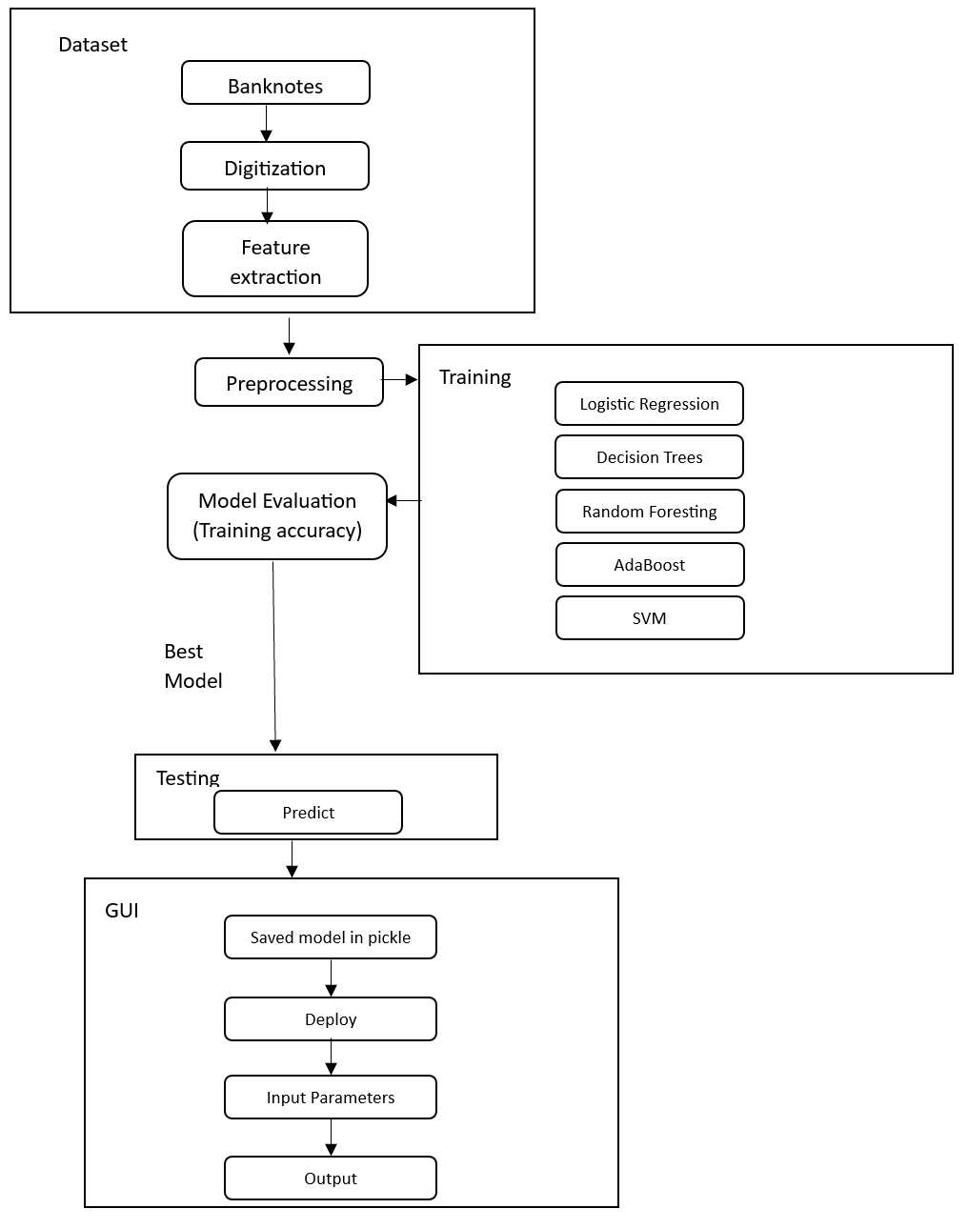

**ALGORITHM**

**Dataset Collection:** Data was obtained from images of both genuine and counterfeit banknote-like specimens. An industrial camera, normally utilized for print inspection, was used for digitalization. The completed photos are 400x400 pixels in size. Grayscale images with a resolution of roughly 660 dpi were gathered because of the object lens and distance to the researched object. To extract features from photos, the Wavelet Transform tool was utilized.

**Data Preprocessing:** The data is prepared for the training phase by analyzing it using Seaborn and Matplotlib. Various graphs are plotted to check if the data is normalized. It is found that kurtosis and entropy features have instant peaks in the distribution plots. The data goes through feature scaling to normalize the data to ensure overfitting might not take place.

**Model Selection and Training:** The supervised machine learning algorithms used in the comparison of performance accuracies are:

1. Logistic Regression: It is a probabilistic and discriminative binary classification technique. It is similar to linear regression but uses the sigmoid function for classification purposes.
$$σ\left(a\right)=\frac{1}{1+ⅇ^{-a}}$$

2. Decision Tree: It is a probabilistic classifier with a tree-like structure that splits the data based on the attribute with the highest information gain. It decides by traversing from the root node to its leaf nodes. Each level is a decision made from the root node.
$$Gain \left(S,Ai\right)=H\left(S\right)-\sum{P\left(Ai\right).H(Sv)}$$

3. Random Forests: It is an ensemble machine learning algorithm consisting of multiple weak decision tree classifiers. The number of trees increases when the variables used to split each node decrease. Each tree chooses the features randomly using random sampling with replacement and trains on a random subset of the data.
4. AdaBoost: It is an ensemble learning technique combining multiple weak models and create a strong model. It assigns weight for each instance in the dataset and through each iteration focuses on the misclassified instances.
5. Support Vector Machine (SVM): The test samples that have a high probability of being misclassified around the decision boundary are eliminated using the SVM model. The algorithm locates a hyperplane, which is essentially a boundary used for classification, to separate the support vectors.

**Hyperparameter Tuning:** The hyperparameters are adjusted around a maximum of three models for each classifier. The average cross validation scores are then calculated to find the optimal model withing and among the different classifiers.

**Model Testing & Evaluation:** The model is applied to the testing data and evaluated using metrics such as accuracy,F1-score,recall,precision, etc.

**GUI Development:** A Web Application is created using Streamlit and deploying the best model saved in a pickle file (.pkl). The test data can be predicted using the Web App if the banknote is forged or not.

**RESULTS AND DISCUSSION**

The cross-validation accuracy scores on the different classifiers are as follows:

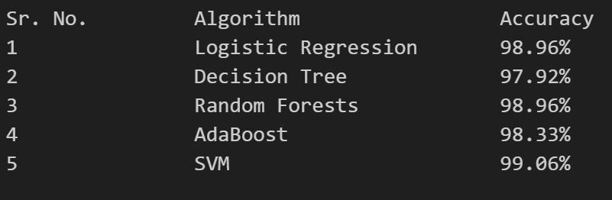

It is found that the SVM model has the highest training accuracy compared to the other classifiers. Hence the SVM model is applied to the entire training and validation dataset. The Model Evaluation score is as follows.

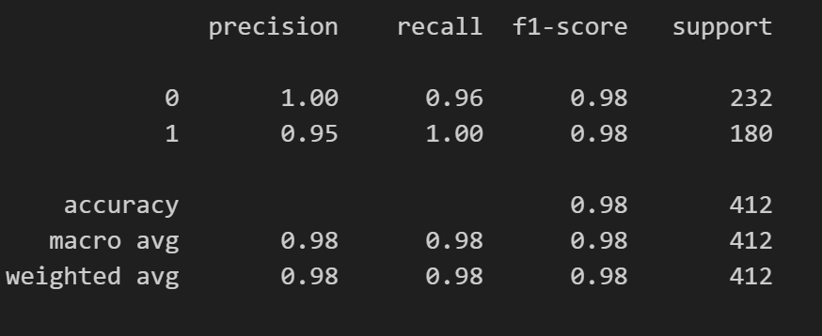

The F1-score shows high accuracy for the model. The accuracy on test data is as follows:

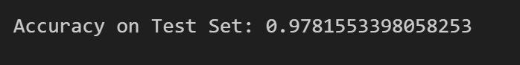

**GUI:**

The Web App contains two pages. The first page i.e. Homepage of the BankNote Authenticator App is as follows.

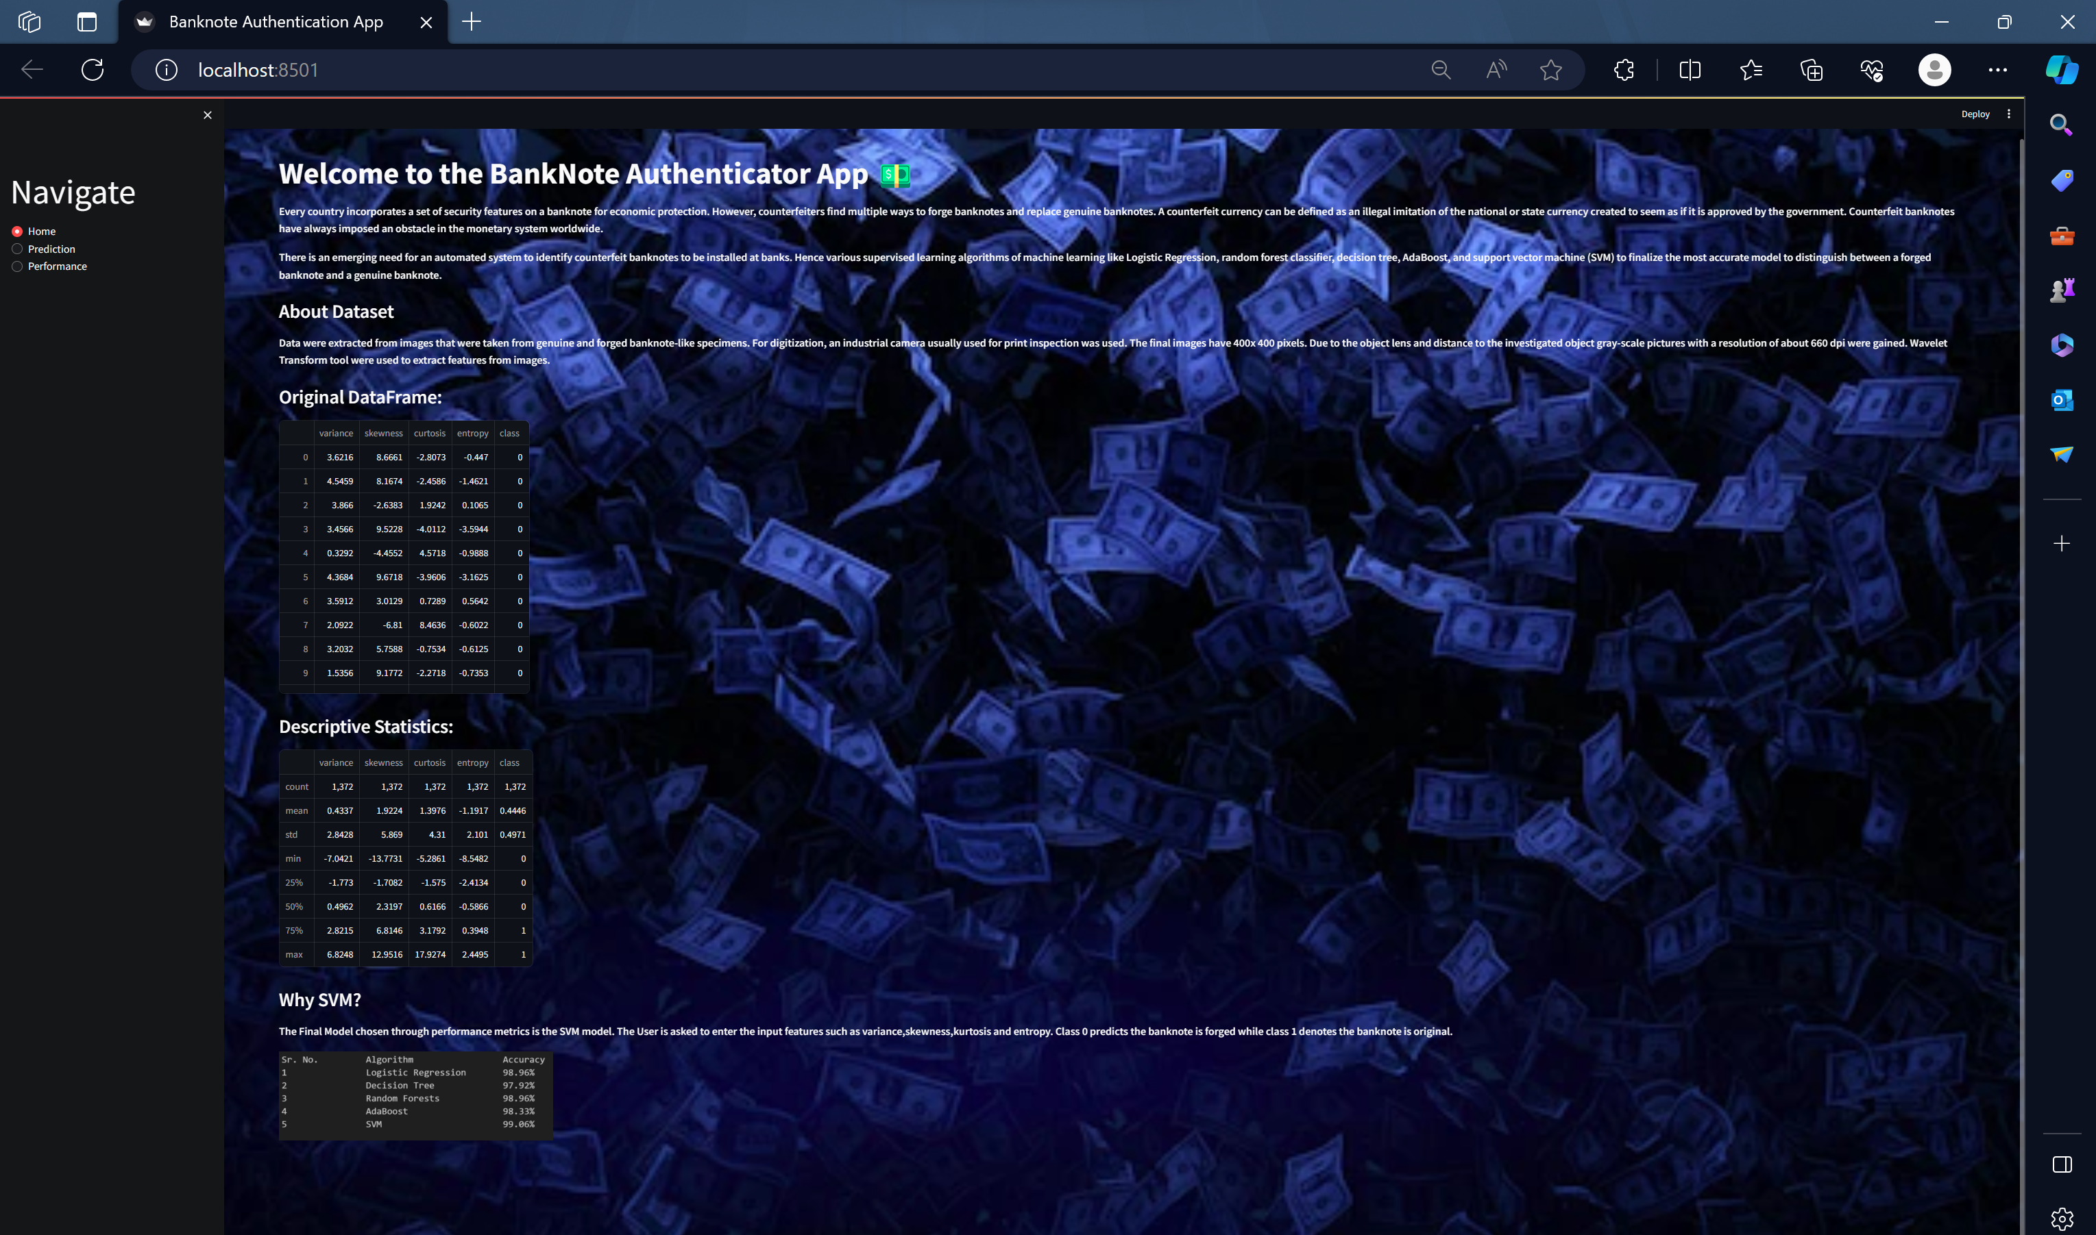

Using the sidebar, the user can navigate to the second page i.e. prediction page. The user is prompted to enter the parameters needed for the prediction.

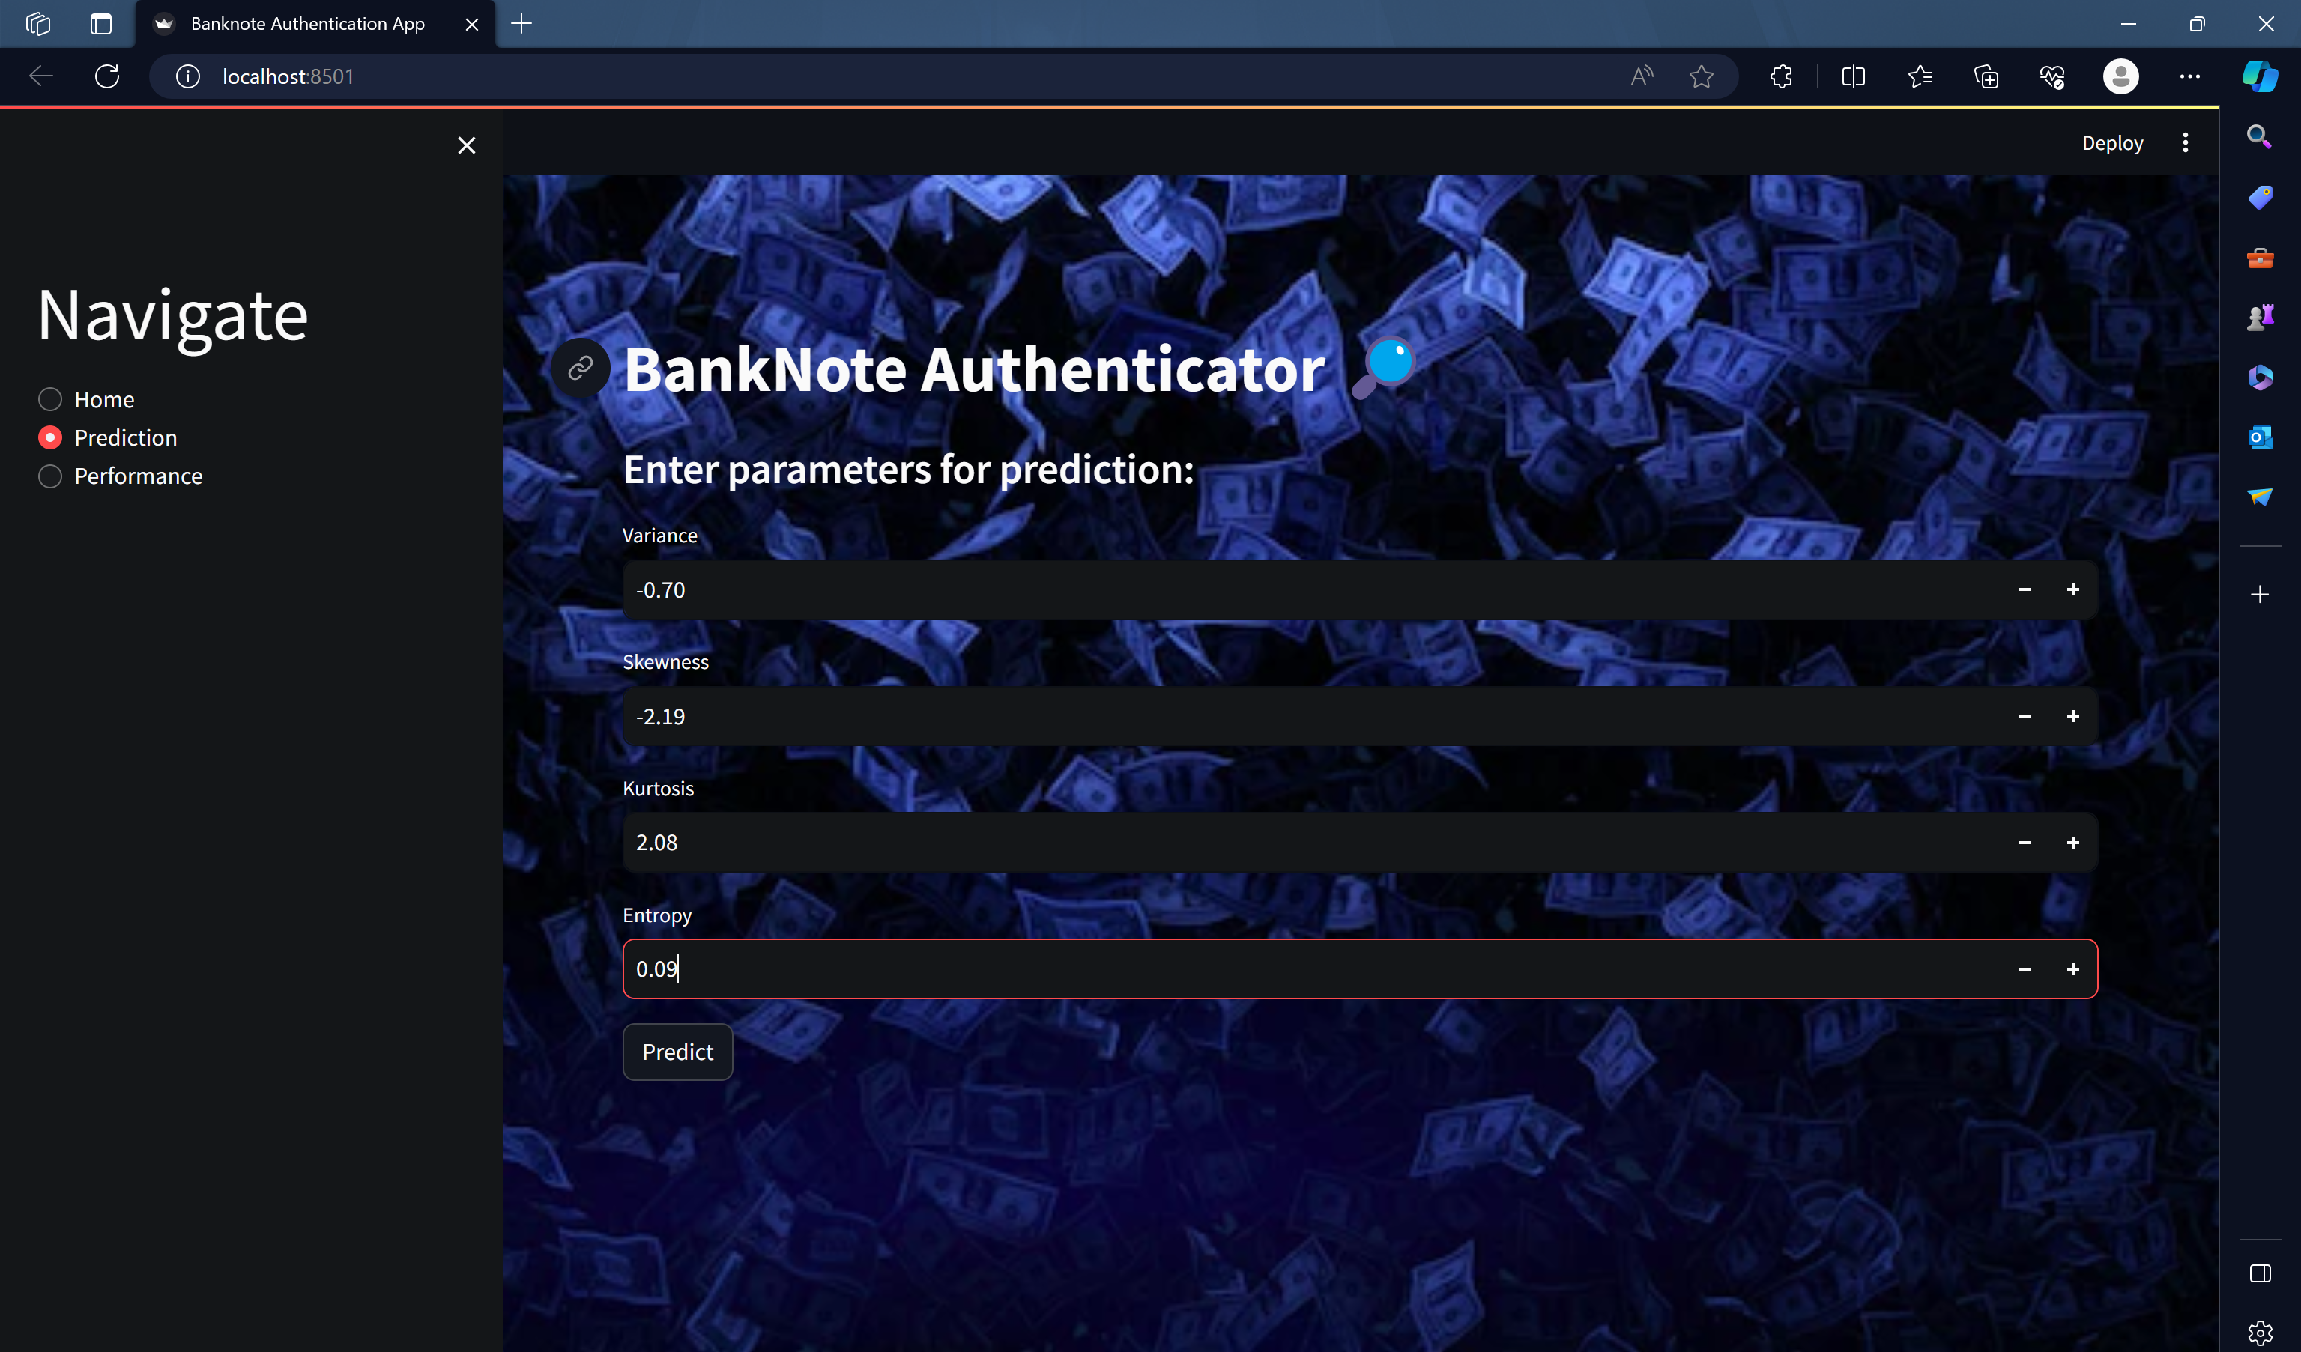

When clicked on the predict button, the predicted class is displayed along with the message of what the binary number 1 or 0 stands for. The below image shows an example of a genuine banknote.

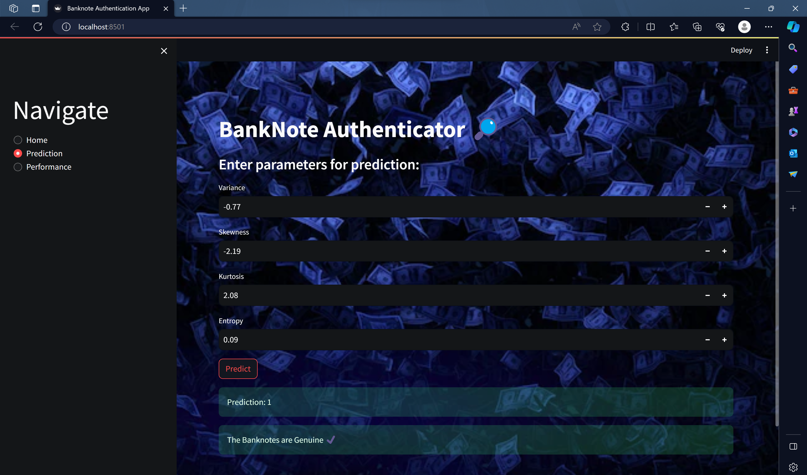

The image below shows an example of a forged banknote.

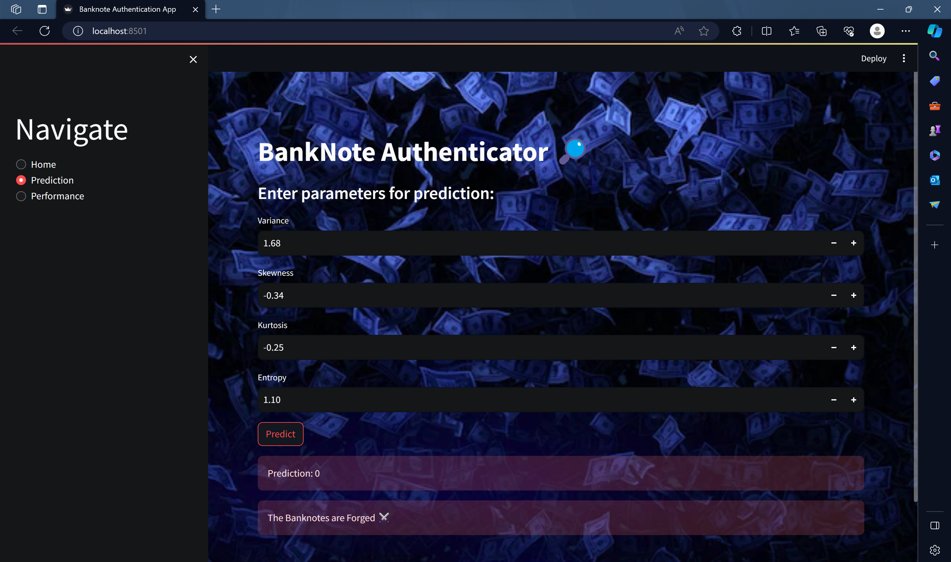

On selection of performance option, the accuracy and confusion matrix of SVM model is shown as below.

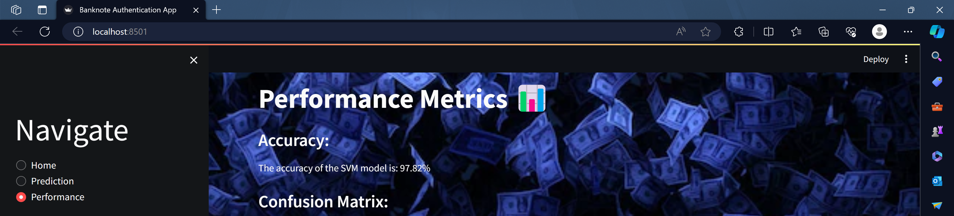

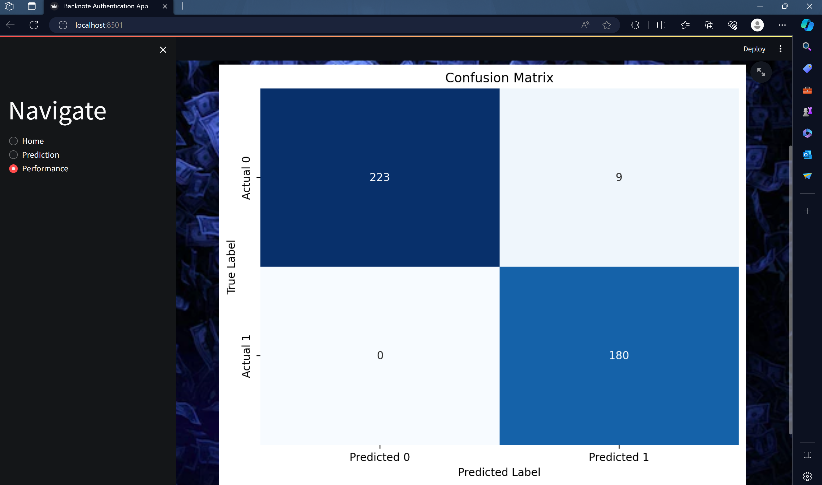

**WORKING:**

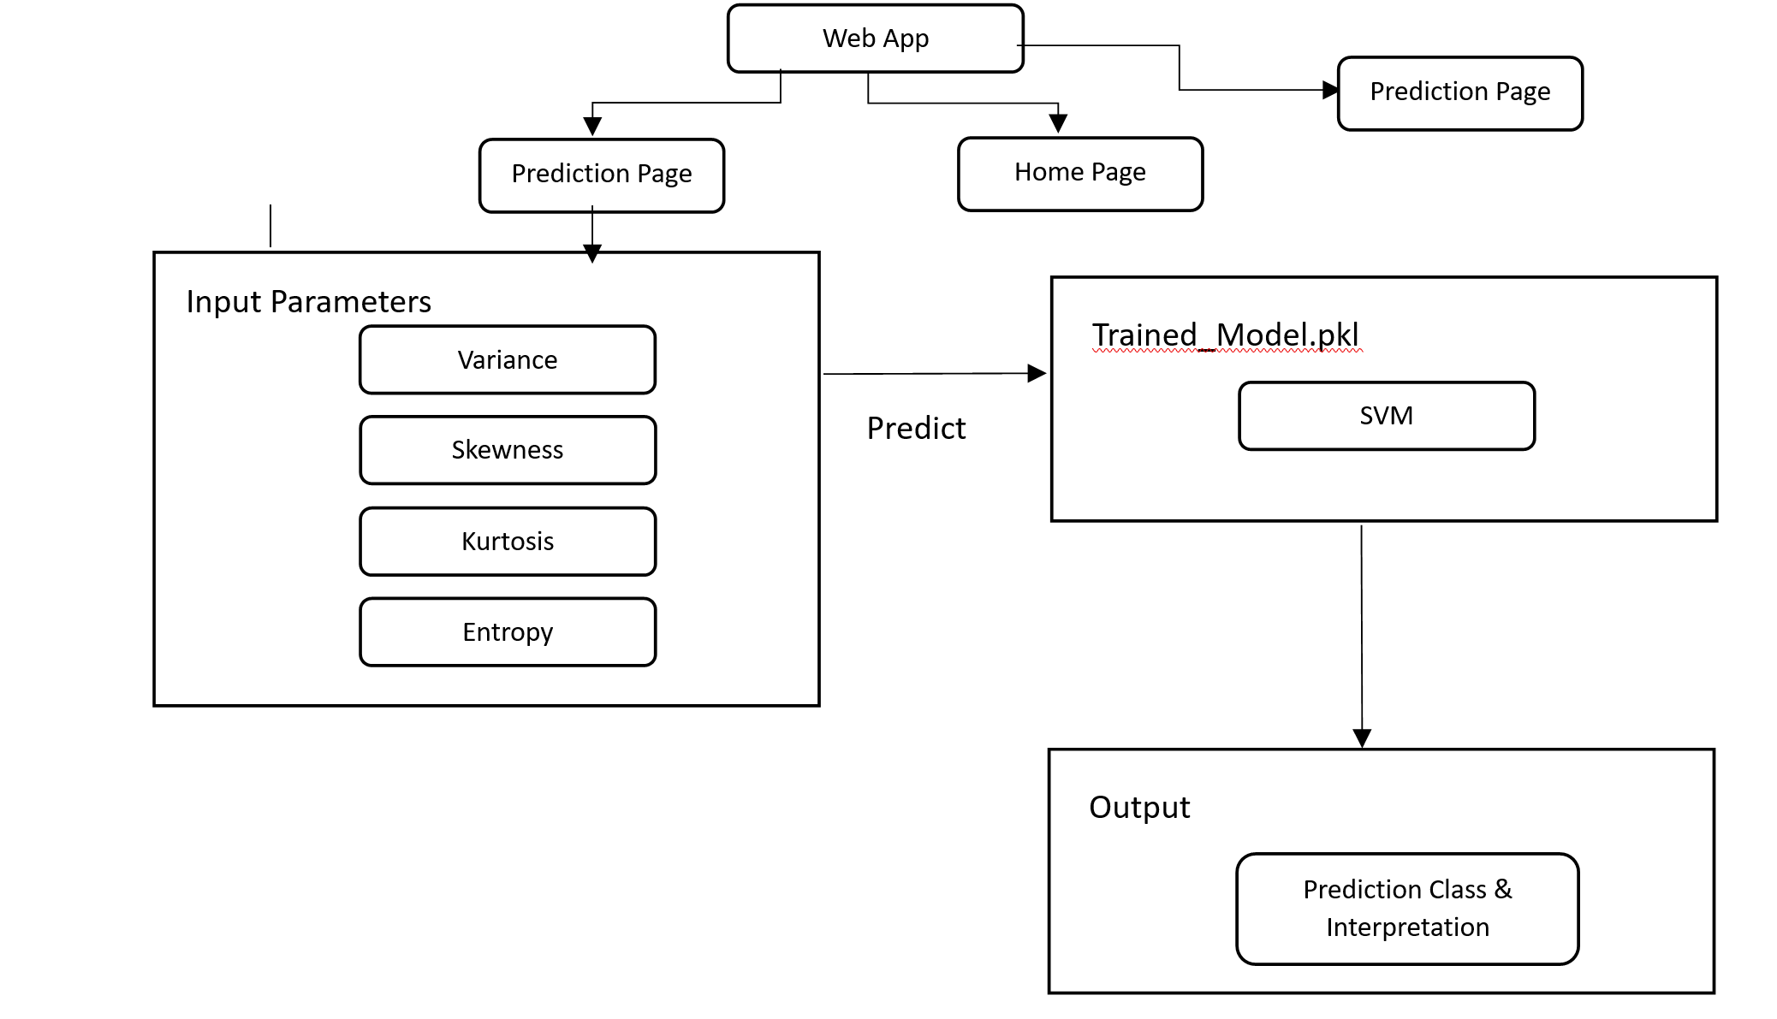

**CONCLUSION**

The comparison of each classifier led to the final model being a support vector machine with a sigmoid kernel. It predicts the test samples with 97.8% accuracy. Based on the results, the model performs well with a mere number of false negatives. Considering the high accuracy of the model, it can be confidently deployed for real-time banknote authentication in practical applications. Furthermore real time banknotes can be used by utilizing OpenCV features and extracting the required features through Python libraries. OpenCV offers robust computer vision capabilities, making it suitable for tasks such as image processing and feature extraction.

**REFERENCES**

1. A. Upadhyaya, V. Shokeen, and G. Srivastava, “Analysis of Counterfeit Currency Detection Techniques for Classification Model,” *International Conference on Computing Communication and Automation (ICCCA)*, Dec. 2018, doi: 10.1109/ccaa.2018.8777704.
2. M. Singh, P. Ozarde, and K. Abhiram, “Image Processing Based Detection of Counterfeit Indian Bank Notes,” *9th ICCCNT*, Jul. 2018, doi: 10.1109/icccnt.2018.8493763.
3. S. Shahani, A. Jagiasi, and R. Priya, “Analysis of Banknote Authentication System using Machine Learning Techniques,” *International Journal of Computer Applications*, vol. 179, no. 20, pp. 22–26, Feb. 2018, doi: 10.5120/ijca2018916343.
4. Ragavi, E. “Banknote Authentication Analysis Using Python K-Means Clustering.” *International Journal of Innovative Science and Research Technology* 5.10 (2020): 80-82.
5. Khairy, R., Hussein, A., & ALRikabi, H. (2021, February 28). The Detection of Counterfeit Banknotes Using Ensemble Learning Techniques of AdaBoost and Voting. *International Journal of Intelligent Engineering and Systems*, *14*(1), 326–339. <https://doi.org/10.22266/ijies2021.0228.31>
6. Bhatia, Kedia, and Shroff, “Fake Currency Detection with Machine Learning Algorithm and Image Processing,” in *Proceedings of the Fifth International Conference on Intelligent Computing and Control Systems*, 2021. doi: 10.1109/ICICCS51141.2021.9432274.
7. Khairy, Rihab Salah, Ameer Saleh Hussein, and Haider TH Salim ALRikabi. "The Detection of Counterfeit Banknotes Using Ensemble Learning Techniques of AdaBoost and Voting." International Journal of Intelligent Engineering & Systems 14.1 (2021).
8. Wang, A., Goldsztein, G., & Sun, Z. (2022, August 31). Banknote Authentication Using Logistic Regression and Artificial Neural Networks. *Journal of Student Research*, *11*(3). https://doi.org/10.47611/jsrhs.v11i3.3777
9. A. Yadav, T. Jain, V. K. Verma, and V. Pal, “Evaluation of Machine Learning Algorithms for the Detection of Fake Bank Currency,” *JOURNAL OF ALGEBRAIC STATISTICS*, Jan. 2021, doi: 10.1109/confluence51648.2021.9377127.
10. Sharma, Prathap, and J. Hussain, Eds., “A Comparative Investigation on the use of Machine Learning Techniques for Currency Authentication,” *First International Conference on Artificial Intelligence Trends and Pattern Recognition (ICAITPR)*, 2021, doi: 10.1109/ICAITPR51569.2022.9844207.
11. A. K. Rout, A. Shety and K. Modekurti, "Counterfeit Regulation through Machine Learning Approach and Deployment in Dockers," 2022 12th International Conference on Cloud Computing, Data Science & Engineering (Confluence), Noida, India, 2022, pp. 500-507, doi: 10.1109/Confluence52989.2022.9734203.
12. Pallavi, S., et al. "FAKE CURRENCY DETECTION." *International Research Journal of Modernization in Engineering Technology and Science (4076-4081)* 4.06 (2022).
13. G and KS, “MACHINE LEARNING ALGORITHM EVALUATION FOR DETECTION OF FAKE BANK CURRENCY,” *International Research Journal of Modernization in Engineering Technology and Science*, vol. 5, no. 7, Art. no. 2582–5208, Jul. 2023.
14. Bharti and Sharma, “A Review on Fake Currency Detection and Image Quality Improvement,” *International Journal of Scientific Research & Engineering Trends*, vol. 9, no. 3, Art. no. 2395–566X, Jun. 2023.
15. S, Vignesh MK, Kumar B, and V, “Sujitha, S. ‘FAKE CURRENCY NOTE DETECTION USING SPRINT ALGORITHM.,’” *International Journal of Emerging Technology in Computer Science & Electronics (IJETCSE)*, vol. 30, no. 2, Art. no. 0976–1353, Mar. 2023.

**Bank Note Authentication using Machine Learning Techniques. Literature Study.**

|  |  |  |  |  |  |  |  |  |  |
| --- | --- | --- | --- | --- | --- | --- | --- | --- | --- |
| NO | REFERENCE | OBJECTIVES | PROBLEM STATEMENT | METHODOLOGY | DATASET | ALGORITHM | ADVANTAGE | DISADVANTAGE | PERFORMANCE MEASURE VALUE |
| 1 | 1. Upadhyaya, V. Shokeen, and G. Srivastava, “Analysis of Counterfeit Currency Detection Techniques for Classification Model,” *International Conference on Computing Communication and Automation (ICCCA)*, Dec. 2018, doi: 10.1109/ccaa.2018.8777704. | 1. Compare and Analyze between Logistic Regression and Linear Discriminant Analysis (LDA) models. 2. Realize the better model for banknote authentication. 3. Predict and authenticate currency notes. 4. Calculate the average accuracy for each model. | 1. Banknote counterfeiting is a major threat to a country. 2. The crime rates has rapidly increased due to forged banknotes. 3. Banks and counterfeiters have been in a constant race to stop each other. | The dataset was taken from the UCI machine learning repository donated by the Helene Darksen. The dataset had 1372 instances in the proportion 55:45. The dataset was divided using the Bernoulli’s function with different proportions as 70:30 and 60:40. The data was simulated 20 times for both LDA and Logistic Regression models. | 1. 55% genuine currencies and 45% forged currencies were obtained. 2. Variance, skewness,kurtosis and entropy data were collected. 3. Target variable in which the banknote is identified as genuine by the value 1 and 0 for forged currencies. | 1. Classification using logistic regression. (99.2%) 2. Classification using Linear Discriminant Analysis / Fisher Linear Discriminant. (98.1) | Models can be designed and developed using mathematical and statistical techniques with better performance and accuracy.  Logistic Regression is a better classification model with high accuracy in both training and testing sets. | Model assumes linear relationship between independent variable and dependent variable.  Both are simple models that may not comprehend any non-linearity. | Logistic Regresion Model with an accuracy of 99% on training set and 99.2% on testing set.  LDA Model with an accuracy of 98.3% on training set and 98.1% on testing set. |
| 2 | M. Singh, P. Ozarde, and K. Abhiram, “Image Processing Based Detection of Counterfeit Indian Bank Notes,” *9th ICCCNT*, Jul. 2018, doi: 10.1109/icccnt.2018.8493763. | 1. Analyze the security threads on Indian banknotes. 2. Conduct image processing on the banknote. 3. Employ k-means cluster unsupervised learning to detect a forged banknote. 4. Propose a cost-effective and robust ML model. | 1. Apprehension on using banknotes as the principal form of money matters. 2. Security features of banknotes are different for each nation. 3. Major challenge to track down counterfeited banknotes due to their rapid adaptability. | Pre-process the banknote image by transforming the RGB image to a format where the component of the banknote is separated from each other. Use k-means algorithm that divides the data points into k-clusters.Euclidean distance calculated and combined individual distance to get results.  The alternate method is segmentation of the latent image of the currency note after measuring the skewness using an equation, encoded using HOG decriptor. Support Vector Machine (SVM) model was developed, and Gaussian Radial Basis Function was used as the kernel function. | 1. 40 real and 20 fake notes were used to include in the training dataset. 2. Images were taken using a high-definition camera with resolution of 8MP on a mobile phone. | 1. Latent image training using SVM model and Gaussian Radial Basis Function. (100%) 2. Security thread images classified using a clustering algorithm i.e., k-means algorithm. (90%) | Real time images were chosen with accurate pre-processing.  Latent image classified using SVM model showed high accuracy and high number of true positives. | Training Dataset was limited to only 60 banknotes in total.  Resolution of camera is not an ideal measurement for capturing high quality images. | Security thread images classified through k-means algorithm show 90% accuracy.  Latent images classified through SVM model show 90% accuracy. |
| 3 | S. Shahani, A. Jagiasi, and R. Priya, “Analysis of Banknote Authentication System using Machine Learning Techniques,” *International Journal of Computer Applications*, vol. 179, no. 20, pp. 22–26, Feb. 2018, doi: 10.5120/ijca2018916343. | 1. Create an SVM model using a kernel function. 2. Calculate the performance measure of the model. 3. Compare the result to that of a BPN model. | 1. Counterfeiters introduce forged banknotes to disrupt the financial market. 2. No efficient algorithm was created through ML to detect fake banknotes. 3. ATM machines are incapable of identifying a forged banknote without a proper system. | The supervised learning model is deployed in GNU Octave. The dataset is divided in the ratio of 80:20. The kernel function is used to project the data in higher-dimensional space in SVM. After the visualization of the data the accuracy of the model is measured. A comparative study is conducted using the hold-out method and compared to a BPN using a ROC curve. | 1. The dataset is obtained from UCI ML repository. 2. It contains 5 attributes and in a balanced ratio of 55:45. | Supervised learning: Support Vector machine. (98.6%) | SVM lacks in predicting accurately forged banknotes. | The back-propagation neural network performs better than a SVM. | Accuracy : 98.6% |
| 4 | Ragavi, E. “Banknote Authentication Analysis Using Python K-Means Clustering.” *International Journal of Innovative Science and Research Technology* 5.10 (2020): 80-82. | 1. Examine two data sets from open ML datasets. 2. Group datasets into clusters based on their similarities. 3. Apply the k-means clustering algorithm to train the model to detect forged and genuine notes. | 1. Dataset cannot determine whether a banknote is original or fake. 2. Forged banknotes are a major problem for banks. 3. A robust system has not yet been developed to identify forged notes. | The algorithm used on the dataset is K-means algorithm to detect the forged banknote based on the variance and skewness. Data is normalized and similar data points are grouped to form clusters. Two clusters are obtained containing forged and genuine banknotes. | 1. Dataset images are taken from open ML containing extracted features with wavelet transform. 2. Two attributes V1 and V2 exist in the dataset. | 1. Unsupervised learning technique, K-means clustering algorithm was employed to get two clusters. | The clusters formed using the K-means algorithm are stable. | Cluster may not be entirely reliable due to the existence of tolerance.  There exist only two parameters.  Data points of features of genuine banknote are less dispersed than the forged. | Moderate performance |
| 5 | Khairy, R., Hussein, A., & ALRikabi, H. (2021, February 28). The Detection of Counterfeit Banknotes Using Ensemble Learning Techniques of AdaBoost and Voting. *International Journal of Intelligent Engineering and Systems*, *14*(1), 326–339. https://doi.org/10.22266/ijies2021.0228.31 | 1. Build advanced identification techniques to identify the security features of a genuine banknote. 2. Develop a model with algorithms of AdaBoost and Voting consisting of ensemble methods to fight against counterfeiting. 3. Experiment with 10 algorithms to find the perfect ensemble method. | 1. Increased flow of counterfeit banknotes seen as a subset of the issue on the flow of physical currency in the first place. 2. Investors and financial institutions are exposed to risk and income loss. 3. Forged banknotes are inbuilt with security features. | A total of ten algorithms were employed. Among these algorithms the major ensemble techniques AdaBoost and Voting are used. The dataset was acquired from UCI machine learning repository. The datasets are trained and tested with algorithms. The experiments were run with the help of WEKA (Waikato environment for knowledge analysis.) | 1. The dataset contains images of both original and forged banknote like samples. 2. Consists of three features and the fourth one is called entropy. 3. The dataset consists of 200 samples of old banknotes which is further divided into 100 samples of genuine and counterfeit notes. | 1. Naïve baye algorithmic model dealing with conditional probabilities. (98.3%) 2. K-Nearest neighbor classification method employing the use of clusters. (99.9%) 3. Fuzzy nearest neighbor classifier like KNN. (99.80) 4. Sequential minimal optimizaation used in training SVM’s. (98.9%) 5. Logistic regression classifier algorithm. (99.1) 6. Random Forest algorithm derived from regression trees. (99.6%) 7. Multilayer perceptron is also known as artificial neural networks. (99.9%) 8. Decision stump algorithm using one-tier decision tree. (94.5%) 9. Random Tree algorithm. (98.3%) 10. AdaBoost and Voting ensemble algorithm with JRip using the combination rule of average probabilities. (99.9%) | Two different datasets are used for training and testing.  The combination of ten algorithms paired in nine different ways shows good accuracy rates.  Ensemble algorithmic models are adept in improving the accuracy of individual algorithms. | Better classification results were not obtained.  Techniques other than ensemble methods should be considered.  Adaboost procedure is fast and easy to handle. | The ensemble methods AdaBoost shows 99.9% accuracy whereas the voting ensemble methods shows 100% accuracy. With Swiss franc dataset it shows 99.5% accuracy. |
| 6 | Bhatia, Kedia, and Shroff, “Fake Currency Detection with Machine Learning Algorithm and Image Processing,” in *Proceedings of the Fifth International Conference on Intelligent Computing and Control Systems*, 2021. doi: 10.1109/ICICCS51141.2021.9432274. | 1. Build a model using K-Nearest Neighbor, Support Vector and Gradient Boosting Classifier after image processing. 2. Normalize the dataset to keep it neutral and not biased to any feature. 3. Calculate the Euclidean distance as a metric. | 1. Traditional strategies to regulate counterfeiting became ineffective. 2. Solution to counterfeited banknotes to avoid disruption of economies. 3. Solution is not available on an easy to use basis incorporated into devices. | Analyze and plot each attribute to make a few observations. Data is normalized to keep the feature between 0 and 1. MinMaxScaler is employed to do pre-processing. KNN algorithm, non-parametric used for classification. Support Vector Classifier to plot each point in an n-dimensional plane.  Gradient Boosting Classifier, an ensemble method to create a good model. | 1. Dataset is created by collecting images of both original and counterfeited banknotes using industrial camera. 2. The dimensions of images are 400 x 400 pixels with grayscale pictures of 660 dpi.   Wavelet Transform applied to the images to extract features such as Variance, Skewness, Kurtosis, Entropy and Class of the currency. | K-Nearest Neighbor model created which can be considered as a decision boundary. (99.9%)  Support Vector Classifier model to plot each point in an n-dimensional plane. (98.6%)  Gradient Boosting Classifier, an ensemble method to create a good model. (99.7%) | High accuracy and performance for KNN classifier.  Higher number of true positives for KNN. | The dataset contains a smaller number of samples.  Dataset does not have real-time banknote images. | KNN model : 99.9% accurate.  SVM model:  98.6% accurate  GBC model: 99.7% accurate. |
| 7 | A. K. Rout, A. Shety and K. Modekurti, "Counterfeit Regulation through Machine Learning Approach and Deployment in Dockers," 2022 12th International Conference on Cloud Computing, Data Science & Engineering (Confluence), Noida, India, 2022, pp. 500-507, doi: 10.1109/Confluence52989.2022.9734203. | 1. Implement wavelet transformed images of banknotes.  2. Utilize Random forests and Naïve Bayes algorithms.  3. Design a user-friendly interface using Flask to show the detections made by the model.  4. Use Docker for environment stabilization. | 1. Uncontrolled currency replication without any regulations.   1. The economy collapses due to inflation of forged banknotes. 2. Increase in prices with a massive downfall in currency value. | Dataset was acquired from the ML repository published by University of California, Irvine. Feature interpretation such as an understanding of variance, skewness, entropy, and kurtosis was done. Pre-processing and classification were done using the random forest and naïve bayes algorithm. User-interface was created in flask with Flassger, a swagger API that helps to add fields and create the application with less code. Docker is then employed to stabilize the environment. | 1. Dataset is available on Kaggle under the name ‘Bank Note Authentication UCI Data’. 2. Consists of multiple banknote images that went through variety of operations. 3. Industrial Camera was used for capturing banknote images with size 400 x 400 pixels. 4. Grey-scale images obtained from the raw images and final image is obtained using wavelet transformation to obtain regions of interest. (ROI) | 1. Random Forest to implement feature randomness and creating decision trees. (98%) 2. Naïve Bayes theorem obtained from bayes theorem. (83%) | Random Forest classifier shows high performance and accuracy.  Docker used for deploying the model to standardize the environment.  A user-friendly interface was created to make the prediction easy to use.  Proposes a cheaper and robust model. | Works with only classifier datasets. More prevalent features of banknotes not explored. | The Random Forest model works with an accuracy of 98%.  Naïve Bayes model works with an accuracy of 83%. |
| 8 | Khairy, Rihab Salah, Ameer Saleh Hussein, and Haider TH Salim ALRikabi. "The Detection of Counterfeit Banknotes Using Ensemble Learning Techniques of AdaBoost and Voting." International Journal of Intelligent Engineering & Systems 14.1 (2021). | 1. Supervised algorithms applied to dataset. 2. Apply Random Forest algorithm and Logistic Regression on dataset. 3. Design system using Python. | 1. Fake currency an issue in the current financial market. 2. No smooth transaction of genuine banknotes. 3. Counterfeiters are creating absolute imitation of genuine banknotes. | Apply the real-time object detection algorithm, YOLOv3 on banknote images. YOLO is implemented using the OpenCV or Kera deep learning libraries.  Upload images and classification is done using random forest and logistic regression algorithms. | 1. Visualize the dataset taken from UCI ML repository. 2. Pre-process this data obtained. | Random Forest algorithm using the voting system for class prediction.  Logistic regression as the classifier by fitting the data to a logit function. | Explores different methods to obtain high accuracy. | Not an efficient model.  Overfitting takes place. | Low performance |
| 9 | Wang, A., Goldsztein, G., & Sun, Z. (2022, August 31). Banknote Authentication Using Logistic Regression and Artificial Neural Networks. *Journal of Student Research*, *11*(3). https://doi.org/10.47611/jsrhs.v11i3.3777 | 1. Create a model that accurately differentiates between an authentic and forged banknote. 2. Utilize artificial neural networks and logistic regression to create the model.Split the dataset into sub-datasets to understand the characteristic features better. | 1. Banknotes are still a primary form of transactions even though counterfeiting exists. 2. Traditional methods of regulating counterfeiting are inefficient.   Human errors can exit when manually authenticating banknotes. | Employ ANN with multiple layers to find a relationship between input and output. Include logistic regression model is also developed. Matplotlib and seaborne are used to separate the data and plot the line. SkLearn.metrics was used to evaluate the model. | 1. The dataset was obtained from UCI ML Repository. 2. Data was extracted from 1372 images.   The grayscaleimages have 60 dpi with dimensions 400 x 400 pixels. | ANN of a total 14 layers was the algorithm employed. (100%)  Classification method i.e., logistic regression was also used. (99%) | The logistic regression model is more lightweight.  Theoretically with the given dataset the ANN model performs well. | Real-time images of banknotes were not used. Accuracy of logistic regression model must be improved.  Improve the size of the dataset to find general trends of forged money. | ANN model: 100% accurate  Logistic regression model: 99% acccurate |
| 10 | A. Yadav, T. Jain, V. K. Verma, and V. Pal, “Evaluation of Machine Learning Algorithms for the Detection of Fake Bank Currency,” *JOURNAL OF ALGEBRAIC STATISTICS*, Jan. 2021, doi: 10.1109/confluence51648.2021.9377127. | 1. Develop and compare different ML algorithms. 2. Normalize the data to remove missing values. 3. Use Naïve bayes, Logistic regression and SVM on the dataset and compare accuracies. | 1. Counterfeiting has skyrocketed in recent years. 2. Increased similarity of forged banknotes to counterfeit banknotes. 3. Economic collapse is on the verge. | Dataset is experimented in different test ratios. Use the Naïve Bayes algorithm on the dataset and test accuracy. Calculate prediction accuracy by applying logistic regression and SVM model. Also apply KNN and Decision tree on the dataset. | 1. The dataset was acquired from UCI under the name,‘Machine Learning Fake currency dataset’. | Classifier methods such as KNN, SVM Logistic regression, decision trees and Naïve Bayes theorem. Advanced ML technique LIGHTBGM was also applied. | LIGHTBGM method showed excellent accuracy. | Dataset instances are very less. | LIGHTBGM showed high performance and accuracy. |
| 11 | Sharma, Prathap, and J. Hussain, Eds., “A Comparative Investigation on the use of Machine Learning Techniques for Currency Authentication,” *First International Conference on Artificial Intelligence Trends and Pattern Recognition (ICAITPR)*, 2021, doi: 10.1109/ICAITPR51569.2022.9844207. | 1. Analyze and pre-process the dataset. 2. Apply different ML algorithms and compare. 3. Test and analyze the accuracy of the model. | 1. Challenging task to identify real and forged banknotes. 2. Manual identification of forged notes takes a long period of time. 3. In K-means algorithm, clusters are of large size and densities. | Unsupervised learning approach K-means Clustering is applied on the dataset. Random Forest Classifier is applied with the MSE formula. Support Vector Machine uses the distance of hyper plane as the formula. Logistic Regression uses the logistical parameter curve on the dataset to classify forged banknotes. | 1. Currency data with three variables. 2. Variables are variance, skewness and the binary indicator of the class. | Unsupervised learning method: K-means clustering. (65.4%)  Ensemble learning method: Random Forest Classifier. (99.7%)  Supervised learning: Support Vector Machine. (81.4%)  Supervise classification: Logistic Regression. (98.5%) | Random forest classifier has high performance.  Very easy for governments to classify forged and genuine banknotes. | Image processing techniques are not used.  Optimization using neural networks, | Random forest classifier is 99.7% accurate. High performance. |
| 12 | Pallavi, S., et al. "FAKE CURRENCY DETECTION." *International Research Journal of Modernization in Engineering Technology and Science (4076-4081)* 4.06 (2022). | 1. Build a vgg16 architecture. 2. Build the vgg16 with a convolutional network using deep learning to detect different banknotes with different denominations.   Capture the banknote via a web cam send it for pre-processing through a mobile application. | 1. The Reserved Bank of India has a hard time controlling the circulation of counterfeit banknotes even after demonetization. 2. An ordinary consumer is unaware of the security feature that identifies a genuine banknote.   There is a rising concern of forged currency inflation in India. | A Vgg 16 architecture was developed that uses kernels to cover the entire picture and do pre-processing on it. A rectified linear unit is used to enhance the classification and reduce the time for processing. The CNN model is fed with images that are taken in different light settings. The final output of the model is given out in the form an audio output. | Uses multiple datasets found on the internet including Kaggle opensource website. | Convolutional neural networks is employed that training on the images of banknotes. | Benefits the hearing-impaired due to the output being in the form of an audio.  Takes in real-time images of banknotes. | The dataset is limited hence outcomes are not on an expected level. | nil |
| 13 | G and KS, “MACHINE LEARNING ALGORITHM EVALUATION FOR DETECTION OF FAKE BANK CURRENCY,” *International Research Journal of Modernization in Engineering Technology and Science*, vol. 5, no. 7, Art. no. 2582–5208, Jul. 2023. | 1. Data exploration and data preprocessing is to be done on the banknote’s dataset. 2. Feature extraction and data splitting is the second goal. System should resize the images to NumPy array format. 3. Finally generate the model using LIGHTBGM methods. | 1. Criminals use forged banknotes to disrupt the money supply. 2. ATM and banks lack the technology to identify forged notes. 3. Consumers are left confused to their lack of knowledge to identify a forged banknote. | Pre-processing of the model includes word removal, upper case removal, punctuation removal, etc. It reduced the images to binary values 0 and 1. MATLAB is used for feature extraction and LIGHTBGM algorithms are applied on the dataset. | 1. The dataset is obtained from UCI ML repository. 2. It contains four features and one target variable. | LIGHTBGM algorithms are deployed. | Highly efficient algorithms are used. | Highly complex model.  Dataset is not diversified and improved. | nil |
| 14 | Bharti and Sharma, “A Review on Fake Currency Detection and Image Quality Improvement,” *International Journal of Scientific Research & Engineering Trends*, vol. 9, no. 3, Art. no. 2395–566X, Jun. 2023. | 1. Image processing is done to ensure that the image is converted into binary form. 2. A ML model is developed. 3. Final result and accuracy is calculated. | 1. Traditional machines used for authentication of banknotes are only available to banks and not ordinary consumers. 2. Humans cannot find the difference between fake and original notes just my mere sight. 3. The counterfeiters face no consequence due to illegal transactions. | Different ML models are deployed after image processing. Data preprocessing is done with the help of ML algorithms. | 1. Dataset is obtained from UCI ML repository. | Supervised learning: Logistic regression, LDA, Support Vector machine  Unsupervised learning: K-means clustering | Accurate algorithms. | Complex models. | High performance |
| 15 | S, Vignesh MK, Kumar B, and V, “Sujitha, S. ‘FAKE CURRENCY NOTE DETECTION USING SPRINT ALGORITHM.,’” *International Journal of Emerging Technology in Computer Science & Electronics (IJETCSE)*, vol. 30, no. 2, Art. no. 0976–1353, Mar. 2023. | 1. Pre-process the data. 2. Apply Spring classification. 3. Execute feature extraction and selection. | 1. Printing technology has advanced leading to high quality imitations of currency. 2. Counterfeiting is a problem for business and banks. 3. Counterfeiters constantly adapt to change currencies and forge rea currencies. | The dataset is first pre-processed using a function called random under sampling and then explored to check if it is balanced properly. Data analysis is done to clean and modify the data. After data visualization on graphs the sprint algorithm is applied. The segmentation of attributes is done with the help of Gini index. | 1. The dataset contains variance, asymmetry, kurtosis, and image entropy. | Sprint classification algorithm is implemented where the histogram is linked with nodes. | The algorithm is simple and easy to understand.  Web UI developed to display the results.  Currency features are learned layer by layer. | More exploration is not done on the accuracy of the model | High performance |